2019 e-ICON World Contest Guidelines

1. Background
○ To nurture global next-generation e-Learning human resources by providing both domestic and international students a chance to engage in international cooperation activities
○ To develop e-Learning contents that are utilizable in the international education environment by forming a multi-national group, promoting social and cultural understanding
2. Overview
○ Title: The 9th e-ICON World Contest [e-learning International Contest of Outstanding New Ages]
○ Date: August 18 (Sun.) – August 24 (Sat.), 2019 (7 days)
○ Venue: Hanwha Resort, Busan, Republic of Korea
○ Host: Ministry of Education (MOE), Republic of Korea
○ Organizer: Institute of APEC Collaborative Education (IACE)
○ Sponsors
- Overseas: Education ministries and related organizations of participating countries
- Domestic (ROK)
- Pusan National University Software Education Center
- 17 Provincial Offices of Education
- APEC Learning Community Builders-Entrepreneur Committee (ALCoB-EC)
○ Participants: approx. 100 contestants
- Overseas: 12 advisory teachers, 26 high school and vocational high school students
(1 team nominated by each nation; each team composes of one teacher and two students)
- Domestic (ROK): 21 advisory teachers, 42 high school and vocational high school students
(Each team composes of one teacher and two students)
※ Teachers should apply along with a pair of students and will play a leading role as advisors
- Global group building: 1 overseas team & 1 Korean team to make up a global group
3. Procedures
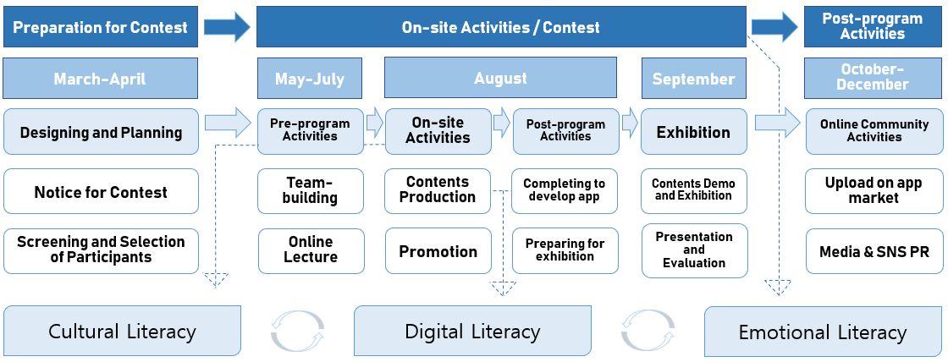
4. Main Contents
○ Outline: Form 21 global groups through the recommendation of youth by Korean & overseas educational institutions, who have distinguished capabilities in e-learning; engage in collaborative development activities on application development as well as its competition
○ Pre-program Activity(Online): Receiving basic online education, including educational ICT; draft an e-learning application development proposal, and make initial version through team communication platform(Google drive)
○ On-site Activity: Revise and supplement e-learning materials developed throughout the Pre-program activity through collaborating with team members, and come up with measures to apply them into real-world situations
- Date/Venue: August 19-23, 2019 (excluding arrival, departure day) / Hanhwa Resort, Busan, ROK
○ Post-program Activity(Online): Each team makes presentation on their creative content; an outstanding team is selected as a result of evaluation; exhibit their work during Edu-tech Fair 2019; exhibitions and demonstrations are held for the general public audience
- Edu-tech Fair (2019): End of September 2019/ COEX (Seoul, Korea) (tentative)
5. Awards and Utilization of Outcomes
○ Awards and additional prizes
Classification |  | Details
Participating Students | Award certificate | - 1st prize: Award from Korean Minister of Education (MOE)  - 2nd ~ 3rd Prize: Award from the Chairman of Institute of APEC Collaborative Education  Awarding institutes are subject to change, depending on those interested in the Contest
○ Utilization of prize-winning content
- Prize-winning content will be utilized as instructional materials in the actual field of education
- Prize-winning contents will be uploaded on the e-ICON World Contest webpage (www.alcob.org).
- All the application must be uploaded in the application store (Playstore, etc.)
6. Guidelines for Participating in the Event
○ Participants: Approx. 100 participants
- Overseas: 13 teams (1 team nominated by each country; each team composes of one teacher and two students)
- Domestic (Korea): 21 teams (Each team composes of one teacher and two students)
- 13 Global groups: 1 overseas team & 1 Korean team to make up a global group
- Two advisory teachers (1 Korean +1 Overseas) will oversee individual global groups
- For 4 teams composing of only Korean ones, two (2) Korean teachers would oversee their groups
○ Eligibility
- The target contestants of e-ICON this year is confined only to high school students
- Each participant must receive prior consent and submit a recommendation letter from the principal of his/her school.
- Students who have received awards in ICT-related contests or those with an equivalent ability are more than welcomed to participate.
- At least one of the team members should be proficient in verbal and written English.
- Students from vocational high schools with content development skills are more than welcomed to join in.
○ Procedures for selecting participants
- (Stage 1) Receive application from students: Receipt of application forms to relevant Ministries or Institutes (Overseas→Ministry of Education in each country; ROK→organizer, IACE)
- (Stage 2) Screen and Nominate 1 team from each country: For overseas participants, 1 team will be nominated by the Ministry of Education of each participating country; ROK participants are screened by the organizer, IACE
- Each country is requested to express its willingness to participate in the 9th e-ICON World Contest no later than May 31 Friday
- After expressing the willingness, each country is requested to send an application of a team by June 7 Friday, to the concerned staff (Myungsun Park (Mr.), pms@alcob.org, +82-70-4640-1206)
- (Stage 3) Confirmation & announcement of final participants
- Official notifications will be sent to each participant and posted on the official e-ICON website (www.alcob.org)
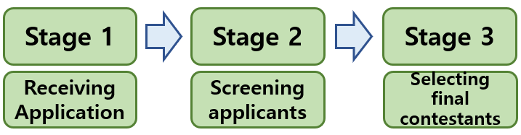
7. Guidelines for Participating in the Event (Continued)
○ Required documents
- Participant Recommendation Letter, Application Form for teachers and students, Written Oath Form, Participant Proposal Form (one copy each)
- See Appendices; forms are also available for download on the official e-ICON website (www.alcob.org)
○ Documents submission
- The person in charge within the Ministry of Education in each country must collect and submit the documents (by e-mail only: pms@alcob.org)
- Contact: Myungsun Park (pms@alcob.org, +82-70-4640-1206)
○ Development Operation
- Android environment must be the basis for the application development operation
8. Stipulations and Notes for Applicants
○ Copyright for the final application
- The copyright of all entries is held by the organizers and the organizers have the right to adjust the work to other forms
- Contestants are liable for any legal disputes raised by the copyright holder in the case of improper conduct in exploiting the copyright without the consent from the copyright owner; thus, prior consultation with the owner of the content that will be used as part of the application is strongly recommended

9. Support for nominated contestants
○ Travel expenses and accommodation
- Round-trip flight tickets from/to the capital city of each participating country to/from the adjacent domestic airport in Korea
- Accommodation during the contest (2 or 3 participants share a room)
○ Meals and Snacks
- Meals are provided by IACE (3 times a day)
- Snacks are also provided by IACE

IACE, Institute of APEC Collaborative Education,
80, Cheomdan-ro, Dong-gu, Daegu, Republic of Korea, 41062
http://www.alcob.org, Tel: +82-70-4640-1206, Fax: +82-53-963-2610
[Appendix 1] Procedure
Category |  | Schedule | Detailed Information
Notice of Willingness  to Participate |  | By May. 31 (Fri.) | - Provide notice of willingness to participate in the contest to the organizer, IACE, via email
Application of Participants | Domestic | By May. 17 (Fri.) | - 21 teams would be screened and selected by the preparatory committee of e-ICON World Contest
Application of Participants | Overseas | By June. 7 (Fri.) | - Recommend 1 team for each country (a total of 13 teams)
Announcement of Final Participants | Domestic | May. 24 (Fri.) | -Notice posted on the official website (www.alcob.org)
Announcement of Final Participants | Overseas | June. 7 (Fri.) | -Notice posted on the official website (www.alcob.org)
International Capacity Building Contest | Pre-activity  (Online) | June. 10 (Mon.)  - August. 17 (Sat.) | - Global group building (1 Korean + 1 Overseas)  - Training on content development (online lectures on  content development)  - Design and the develop content (initial(draft) version)
International Capacity Building Contest | On-site activity  (Offline) | August. 18 (Sun.)  - August. 24 (Sat.) | - Opening ceremony and orientation, Ice-breaking  - On-site cooperative developing of an educational mobile app proposed
International Capacity Building Contest | On-site activity  (Offline) | August. 18 (Sun.)  - August. 24 (Sat.) | - Presentations on content and evaluation  - Awarding and closing ceremony
International Capacity Building Contest | Post-activity (On, offline) | September  - November | - Sharing of content (uploaded on the website, etc.)  - Revision and supplementation of content and the promotion of its  utilization (dissemination to each participating country, etc.)  - Online community activities, including participation in other  international cooperation events, etc.
International Capacity Building Contest | Post-management (On, offline) | September  - November | - Content uploading (Playstore, etc.)  - Content modification & development  - Continuous online activities, etc.
[Appendix 2] Participant Recommendation Letter Form
Application no.

Participant Recommendation Letter
9th e-ICON World Contest
Name of the Institution | Position | Name | Contact Number  (Must be Written) | E-mail  (Must be Written)
 | Teacher
 | Student
 | Student

Teacher’s experience in guidance | Awards background in the field of ICT-based education,  international education collaboration, or related areas
( ) years in education using ICT
( ) years in international education collaboration

The persons named above are exceptionally motivated and are enthusiastic delegates in the field of ICT and international education collaboration. On this account, I highly recommend them as participants in the 9th e-ICON World Contest

Date: __/__/2019

(Principal’s or professor’s name and signature)

[Appendix 3] Application Form

The 9th e-ICON World Contest Application Form

A. PERSONAL INFORMATION
Family Name (Surname): | First Name:
Full Name (As shown in your Passport): | Gender: □ Male □ Female
Nationality: | Passport No.:
Telephone: | Mobile:
Email address: | Occupation:  □ Student □ Teacher
School/Grade:

Meal Preference:  □ Standard □ Vegetarian □ Halal Food □ Other (please provide details): | T-shirt size (e-ICON T-shirt will be provided)  □ S □ M □ L □ XL □ 2XL □ 3XL

B. LANGUAGES (Please include all language spoken and indicate the level of proficiency)
Languages | Read | Write | Speak | Understand
 | □ Basic  □ Intermediate  □ Advanced | □ Basic  □ Intermediate  □ Advanced | □ Basic  □ Intermediate  □ Advanced | □ Basic  □ Intermediate  □ Advanced
 | □ Basic  □ Intermediate  □ Advanced | □ Basic  □ Intermediate  □ Advanced | □ Basic  □ Intermediate  □ Advanced | □ Basic  □ Intermediate  □ Advanced
 | □ Basic  □ Intermediate  □ Advanced | □ Basic  □ Intermediate  □ Advanced | □ Basic  □ Intermediate  □ Advanced | □ Basic  □ Intermediate  □ Advanced

C. QUALIFICATION/EXPERIENCES (List qualification/experience related to the contest)
Date | Details | Reward Results

D. MOTIVATION
Please explain:
1. Why you want to be a part of this contest, what you hope to achieve and
how you intend to use the knowledge/experience gained.
2. Why do you think you should qualify to participate in the contest?

E. WRITTEN OATH
WRITTEN OATH
As a participant in the e-ICON World Contest, hosted by the Korea Ministry of Education (MOE), organized by the Institute of APEC Collaborative Education (IACE), I hereby vow sincerely to comply with the following terms.

1. I will not produce content that has been plagiarized or copied from any existing ICT-based educational media, or output derived from the research of others.

2. I will not submit output previously produced by other educators or research schools and utilize it as my own personal achievements.

3. If my submission has been found to contain plagiarized material or to be created through the participation of a proxy, I will comply with the corresponding penalties.

4. I will adhere to the other terms as required in the course of the event.

Date: ________/________/2019

Name of School:
Name and signature:

F. GUARDIAN’S CONSENT
□ Relationship to the applicant:
□ Guardian Name:
□ Mobile:
□ Email address:

I hereby give my consent for the above-named applicant to participate in
the 9th e-ICON World Contest.
Signature: Date: ________/________/2019
[Appendix 4] Participant Proposal Form
PROJECT PROPOSAL
Mobile APP Name
Related SDGs | e.g., SDG#1 (No Poverty)  SDG#4 (Quality  Education) | Related School  Subject | e.g., Social Studies,  Math, Science
Target Education  Level | □ PRIMARY  □ JUNIOR SECONDARY  □ SENIOR SECONDARY | Target Country
□ Background

□ Mobile App Overall Objective

□ A brief summary of the Mobile App

□ Development Tool/Program/Other necessary technology

□ Impact of Mobile App on Teaching & Learning Activities

*ONE Proposal needed per team .
* All Mobile Apps must be Android-based. As long as your app is Android-based, You may use any kinds of programming, software, technical platform, as well as third-party engines, libraries, and middleware provided obey their license.
* You may use extra sheet of paper to complete Project Proposal, if necessary.

